Please note

Please send your application documents for the coaching seminars by e-mail toterezi@wusgermany.deand loch@wusgermany.de

  - Curriculum Vitae
please use the following format: https://europass.cedefop.europa.eu/en/documents/curriculum-vitae
  - Please add a current photo to your CV
  - Copies of your report card and certificates (minimum requirement is a bachelor’s degree)
  - Valid certificate of enrolment if you are currently enrolled for a master’s degree program
  - Short letter of motivation; why would you like to participate in this workshop?

Application deadline for the students of Vlora, Korca and Shkodra Universities is 1 week before the start of the workshop, and application deadline for the students of Tirana, Durres and ElbasanUniversitiesis 10 days before the start of the workshop(participation is limited to 30 students)

Information:
- The application forms for the internship grant can be accessed on our homepage www.surplace-albania.de
Or you can order them at albania@wusgermany.de
Application Deadline: 1August 2017

World University Service (WUS)
in Deutschland

The World University Service (WUS) is an international organization without political or religious affiliations. It is organized in national committees in more than 50 countries worldwide. The WUS considers itself as a community of students, teachers, and employees in the education sector.

The activities of WUS DeutschesKomiteee.V. are especially focused on:
- Educational work in development policy
- International cooperations in the education sector
- Studies for foreigners and reintegration counseling.

Office in Tirana:
Albania Sur-Place Scholarships
Dr. EdaTerezi
c/o DIHA German Association of Industry and Trade in Albania
Rr. Skenderbej 4/7
Tirana
Tel.:++355 68 6680070
Email: terezi@wusgermany.de

Office in Wiesbaden:
World University Service Deutsches Komitee e.V.
Frau Petra Loch
Goebenstraße 35
65195 Wiesbaden
Tel.: ++49 611 9446051
Fax: ++49 611 446489
E-Mail: loch@wusgermany.de
Internet: www.wusgermany.de

For more information, application documents, important dates and more visit:
Internet: www.surplace-albania.de

Facebook : www.facebook.com/surplace.albania

Application training and additional offers for Albanian Students
at Albanian State Universities

Application for training seminars in the following cities:

Tirana (also for Elbasan and Durres)– Shkoder – Gjirokaster – Korce– Vlora

Application deadline is 1 week before the start of the workshop(participation is limited to 30 students)

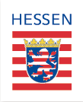

The project is funded by the Hessian Ministry of Economics, Energy, Transport and Regional Development.
Objective - Application Training

Are you in the final stage of your studies or have you already started job hunting?

From making contact, to your portfolio, and up to your job interview, there are many obstacles to overcome until you find a suitable internship or job.

We are offering you a training program, where you can learn how to search for a job that fits your interests as well as your profile, and how to apply properly for this position.

After the workshop you should be able to win over future employers. You will acquire the ability to write an appropriate application letter that fits the position you are applying for, and you will learn how to emphasize your knowledge and skills in your CV according to the new job.

===========================================
Note – Internship Grant
We are happy to keep supporting you thereafter.In case you have found an internship position you are welcome to contact us again.We assist with a grant for three to six months.

Additional information at: www.surplace-albania.de

Job Hunting – Entering the Job Market in Albania

- Can you assess your skills, your occupational outlook, and your wishes for your personal development reasonably and realistically??

- How do you define your professional goals?

- How important are private and professional networks?

Not only do we give answers to these questions in the application trainings, but we also provide useful tips, check lists, consultation, and addresses. In short, everything you need for a successful application and job search.

We put our focus on:

- Cover letter (formal and content-related)
- Letter of motivation
- CV
- Search for jobs / internships
- Networking
- Media (from newspaper to homepage)
- Vacancy notices
- Job interview

At the end of thisfree workshop, you have made your first step toward your career planning.

Congratulations!

Trainings are offered in the following Cities

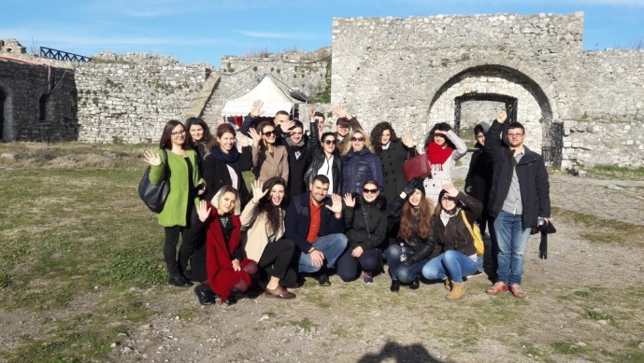

Vlora - 4 June 2017,at Hotel “Pavaresia”

Korca – 15 June 2017, at Hotel “Konti“

Shkodra – 29 June 2017, atHotel „Tradita“

Tirana, Durres and Elbasan – 6 July2017 and 13 July 2017, at Tirana Business Park.

Gjirokastra - 9 July 2017, at Hotel “Çajupi”

Please read carefully which documents you need to add to your application.
After your application you are going to receive more detailed information on the time and place of the seminar.

